* **PF and ESIC: -**
* **PF -** pf stands for provident fund. It is monthly deduction from fixed salary.
* Click on PF and ESIC
* Click on edit icon present in operation table
* Enter percentage
* Click on update
* According to that PF percentage, amount get deducted from fixed salary.

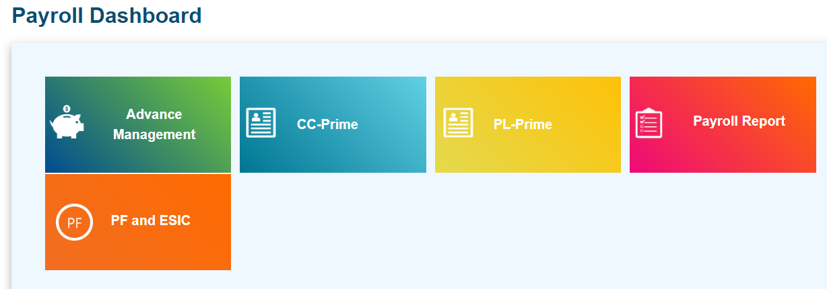

* **ESIC-** Employees State Insurance Corporation (“ESIC”) is a statutory corporate body set up under the [ESI](https://cleartax.in/s/esi-registration) Act 1948, which is responsible for the administration of ESI Scheme. The ESI scheme is a self-financed comprehensive social security scheme devised to protect the employees covered under the scheme against financial distress arising out of events of sickness, disablement or death due to employment injuries.
* Click on PF and ESIC
* Click on edit icon present in operation table
* Enter percentage
* Click on update
* According to that ESIC percentage, amount get deducted from fixed salary.